A Hybrid Intrusion Detection System Fusing Deterministic Finite Automata and AI with Physical Sensor Integration for Cloud Environments

R.V Darsan
School of Computing,
SRM Institute of Science & Technology,
Tiruchirappalli, India
rvdarsan@gmail.com

Afeef Ahmed Shaik
School of Computing,
SRM Institute of Science & Technology,
Tiruchirappalli, India
afeefahmed.shaik@gmail.com

Anapaneya Pal
School of Computing,
SRM Institute of Science & Technology,
Tiruchirappalli, India
rvdarsan@gmail.com

Dr. R. Mallika
School of Computing,
SRM Institute of Science & Technology,
Tiruchirappalli, India
rvdarsan@gmail.com

Abstract— Cloud infrastructures of modern days are under attack from very sophisticated and experienced hackers that often make use of both the network and physical weaknesses of the system at the same time. The current Intrusion Detection Systems (IDS) have a major drawback, since they work separately, they do not allow the combining of digital intrusions with physical security breaches. The combination of this architectural flaw with inadequate stateful protocol analysis makes them powerless against multi-vector attacks and high false positive rates. The novel, multi-layered IDS architecture that this paper is going to propose is the one that will be able to synergistically fuse Deterministic Finite Automata (DFA) for high-speed signature matching, an AI engine for zero-day anomaly detection, and physical sensor data integration. The main innovation is the correlation engine that puts network-level alerts in the context of real-time physical events, like server rack tampering. The fusion of cyber-physical data provides a comprehensive security posture that is capable of detecting multi-vector threats that were invisible before while at the same time significantly reducing false positives. The end result is a defense paradigm that is strong, scalable, and low-latency for modern cloud ecosystems.
Keywords—Intrusion Detection System (IDS), Cloud Security, Deterministic Finite Automata (DFA), Artificial Intelligence, Anomaly Detection, Physical Security, Multi-Vector Attack.
I. INTRODUCTION
The shift to cloud computing has become inevitable with its centralised and distributed nature making it a very appealing attack vector for the highly skilled and well-funded cyber adversaries, the contemporary threats are sophisticated one and have already capitalized on such frameworks. They are no longer limited to single exploits, but rather as multi-modal campaigns that elaborate on network-level attacks, such as TCP state exhaustion and protocol manipulation, combined with physical security breaches. Such an aligned attacks with different infiltration methods is a strong challenge to the traditional and rather susceptible security approaches.
Currently existing Intrusion Detection Systems, or IDS, are not prepared well enough to face this situation. Signature-based IDS can identify known threats quite well, but they are slow and dependent on already identified and documented attack methods. Anomaly-based systems, on the other hand, which are trying to recognize previously unknown threats, are often burdened with high false positive rates and costs of computing, thus becoming unsuitable for the large volume and quick pace of cloud computing. The main drawback, however, is the total separation of cyber and physical security monitoring, which not only prevents the detection of a network anomaly associated with a physical event, like server access without permission, but also renders the cyber portion of the threat landscape invisible.
Considering these serious drawbacks, a new approach to the problem has been developed, through which a multi-layered cyber-physical intrusion detection framework is presented for comprehensive and context-aware threat analysis. The design is based on the synergistic combination of three different detection modalities. The first layer includes the use of a Deterministic Finite Automata (DFA) engine which inspects the network traffic in a stateful manner at line-rate. This element exploits the natural ability of DFAs to perform computations efficiently to determine if the protocol handshakes like the TCP three-way handshake are correct and carry out quick matching processes to a selected database of known attack signatures.
An unsupervised AI model is working in the background, which sets up a fluid, multi-dimensional standard of the network's normal behaviour. It does so by studying the telemetry data of the network and subsequently identifying very subtle differences and those that are statistically significant which are the indicators of zero-day exploits that evade signature-based approaches. The most remarkable thing of all, however, is the third layer we developed, a cyber-physical correlation engine. Monitoring parameters like server chassis intrusion, thermal changes, and sound signatures this module takes in and processes the real-time data streams from physical sensors and matches the events with alerts from the network-level detectors. Such a blend not only gives essential situational context, but it also grants a power to the system to tell apart the harmless network anomalies from the serious threats, thus the false positive rate is greatly cut down and the detection of the attacks that are coordinated over both the digital and physical realms becomes possible.
The paper is laid out the following way: The related works are first reviewed, then the system architecture and methodologies are elaborated on in detail. Next, we provide the experimental testing and results, and finally, we discuss our conclusions and the implications of our findings for cloud security, respectively.
II. LITERATURE REVIEW
The transition of intrusion detection paradigms is a consequence of the developing threat landscape that has become very sophisticated. The first attempts were made to streamline the detection technique and the main focus of the research was to improve the pattern-matching algorithms. One of the main areas that were outright determinism from state automation (DFA) was through the GeeksforGeeks' [1] explanation of its theoretical efficiency. A partial DFA for detecting network intrusion is depicted by Mahadevan et al. [12] while there are different studies by Caselli et al. [2] and Tripathi et al. [3] that reveal the DFA's success in protecting the specialized SCADA and IoT protocols. In spite of the progress, the literature highlights the static nature of the signature-based methods as the main drawback rendering them incapable of detecting new zero-day attacks.
The drawbacks of the methods have resulted in a research shift towards the adoption of AI and ML techniques for anomaly detection as main detection approaches. Comprehensive surveys on the topic by Kumar et al. [7] and Aljawarneh et al. [18] have narrated the changing of the statistical methods over the years until the current advanced deep learning algorithms. In order to extract sophisticated features out of raw network telemetry, Abdullah et al. [17] as well as Aldaej et al. [6] have put their main focus on deep learning networks. In addition, the comparative studies conducted by Singh [14] and the reviews on federated learning by Shah et al. [5] show how versatile the application of AI is. However, these surveys also mention the continuous problems such as the heavy requirements of computation, the risk of high false positive rates (FPR) and the system's exposure to getting around with adversarial evasion attacks.
The development of hybrid architectures that capitalize on the complementary strengths of the different paradigms has resulted in the creation of more robust systems. A comprehensive analysis of this area has been presented in a systematic review by Al-Issa et al. [23]. The main hybrid strategy illustrated in the work of Kim et al. [13] is to use machine learning to improve traditional signature-based detection. A step further in innovation is the contribution of Singh et al. [22] with the proposition of a hybrid feature extraction method that enhances classification accuracy. The benefits in terms of system integration include higher robustness and lower overall FPR; nevertheless, such operational advantages remain limited to the cyber domain.
The majority of current literature has incurred a serious shortcoming in its treatment of the interaction occurring between physical and digital attack vectors. In the majority of cases, network security is treated as a separate issue which leads to a significant caveat in the research of cyber-physical security of data centres as indicated by Liu et al. [24]. Such an isolated operational mode presents a tempting opportunity for the attackers; an adversary with access to the physical part of the system can directly compromise the hardware and the resulting network activity will be considered benign in the analysis if physical context is ignored. However, studies like the one conducted by Sharma et al. [11] have not entirely overlooked the concept of intrusion detection systems in sensor networks; rather their focus is peripheral (i.e., on sensor networks) rather than core (i.e., on the cloud infrastructure).
This paper aims to fill this significant gap directly. Through the introduction of a framework that intentionally combines physical sensor telemetry with intrusion data from the network level, our method not only furnishes a more comprehensive and context-sensitive security posture but also surpasses the primitive limitations of the purely digital-dominated systems previously talked about.
III. METHODOLOGY
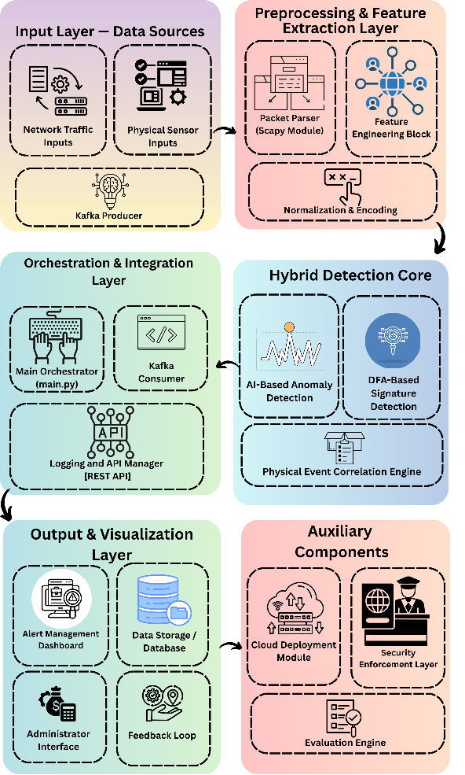
Figure 1: System Architecture
The system that has been put forward employs a hybrid intrusion detection method that merges the deterministic capability of Deterministic Finite Automata (DFA) for signature-based detection with the adaptive intelligence of AI-driven anomaly detection models. The idea behind this design is that it will be able to overcome both known and zero-day attacks in a cloud-based network environment while still being able to detect them in real-time and be scalable at the same time. The methodology is carried out through a structured pipeline consisting of data acquisition & preprocessing, DFA-based signature modelling, machine learning for anomaly detection, co-relation of physical events, orchestration of real-time streaming, and evaluation.
- Data Acquisition and Preprocessing
The first step of this process is to gather and organize network traffic data from both the standard benchmark datasets and real-time network streams. Two famous datasets are used for the purpose of training and validation, NSL-KDD Dataset: A revised version of the KDD'99 dataset that has no duplicate entries and does not present any bias, thus, it is good for testing intrusion detection algorithms on balanced data. CICIDS-2017 Dataset: A wide-ranging recent dataset that imitates the traffic of real networks with labelled benign and various types of attack flows such as DoS, brute force, infiltration, and botnet attacks. Each network packet captured 𝑃𝑖 is portrayed in the form of a structured tuple:
Pi​={src_ip,dst_ip,src_port,dst_port,flags,payload,ti​}

where $t_{i}$denotes the timestamp. Feature extraction is performed to derive both statistical and protocol-level characteristics, forming a feature vector $x_{i}$:
$$x_{i}=[\text{len}(P_{i}),\text{flag}\text{_bits},\text{digit_count},\text{special_char_ratio},\text{entropy}(P_{i})]$$
Their main characteristics are covering the message length, flag structure, character distribution, and payload entropy — all of them are very important for distinguishing between legitimate and not-so-legitimate traffic. The feature vectors are standardized using z-score normalization to achieve numerical stability and uniform scaling for machine learning models:
~i​=σxi​−μ​
where 𝜇 and 𝜎 represent the mean and standard deviation of each feature in the training set. Preprocessing, apart from transformations, also includes timestamp alignment, noise removal, and validation of protocol fields.
B. DFA-Based Signature Detection Module
The signature detection module exploits DFA to model the TCP 3-way handshake, which is further strengthened by the introduction of a custom Authorization Code Number (ACN) for the verification of the handshake. This method makes it possible to verify in a stateful manner the establishment of a session, that is, the traditional IDS tend to overlook this aspect.
The DFA is formally described as:
where:
- $Q=\{q_{0},q_{\text{SYN}},q_{\text{SYN-ACK}},q_{\text{ACN}},q_{\text{ACK}},q_{\text{EST}}\}$is the set of states,
- $Σ$is the input alphabet comprising TCP flags and ACN tokens,
- $δ$is the state transition function,
- $q_{0}$is the initial state, and
- $F=\{q_{\text{EST}}\}$ denotes the set of accepting states is representative of the successful authenticated connections.
The transition function includes the extra ACN verification steps in addition to the standard TCP behaviour. As an instance:
δ(qSYN-ACK​,ACN_valid)=qACN​,δ(qACN​,ACK)=qEST​
Any nonconformity to this anticipated sequence (e.g., absent ACN, wrong ACK ordering, phony SYN packets) results in immediate classification as suspicious. The DFA design is being realized with the help of PyDFA, which provides deterministic, low-latency matching of state transitions even in high-traffic zones. This means that detection of known signature-based attacks will be done with constant-time complexity.
C. AI-Based Anomaly Detection Module
DFA, on the one hand, effectively reveals recognized patterns, while, on the other hand, zero-day and metamorphosing attacks necessitate the use of adaptive intelligence. The isolation of the unearthed attacks and detection thereof has been made possible through the use of machine learning-based anomaly detection, which combines Isolation Forest (IF) algorithm owing to its unsupervised nature and effectiveness on large networks dataset.
Anomaly score 𝑠(𝑥𝑖) is calculated as follows for given feature vector 𝑥~𝑖:
s(xi​)=2−c(n)E(h(xi​))​
where 𝐸(ℎ(𝑥𝑖)) denotes the average path length from the root of the tree to the point 𝑥𝑖 for the ensemble of isolation trees, and 𝑐(𝑛) is the average path length for a binary search tree of 𝑛 samples. Anomalies are more likely to occur at points that have shorter paths leading to them through the isolation process. A dynamic threshold 𝜃 is established through validation and subsequently used for the classification of traffic as either anomalous or normal.
Simultaneously, state-of-the-art deep learning methods, such as Autoencoders and LSTM sequence models, are being investigated for the purpose of analyzing and modeling the time series data in terms of dependencies and high-dimensional feature interactions. The normal traffic patterns are reconstructed by an Autoencoder, and the reconstruction errors are employed in detecting anomalies:
LAE​=∥xi​−x^i​∥2
Packets that have reconstruction errors surpassing a certain threshold set by a machine learning model are considered as anomalies. This combined method allows for the discovery of not only the statistical anomalies but also the behavioural deviations.
D. Physical Security Event Correlation
The system includes the linking of IoT sensor data through Raspberry Pi or Arduino modules in order to deal with multi-vector attacks which consist of network intrusions and physical tampering (e.g., unauthorized rack access or unplugging a cable). Each physical event is signified by a token 𝐸𝑗, which consists of the event type, timestamp, and location metadata.
The correlation function 𝐶(𝑃𝑖,𝐸𝑗) is used to evaluate if there is a temporal and spatial relation between the network event and the physical security event:
C(Pi, Ej) = 1 if |t(Pi) − t(Ej)| ≤ Δt and location match
C(Pi, Ej) = 0 otherwise
In case of having correlation, the system increases the alert level, thus cutting down the false negatives in cases when the attacks are in a combination of cyber and physical areas.
E. Real-Time Streaming and Orchestration
The comprehensive detection pipeline is made to work in two distinct modes:
Batch Mode: Dataset files are processed offline for training, tuning and controlled experiments.
Real-Time Mode: Detection with high throughput online through Apache Kafka which allows the streaming of live traffic in a scalable manner.
Each packet that comes in is subjected to DFA based signature detection and AI-based anomaly detection simultaneously. A main control script manages the orchestration that coordinates the DFA engine, ML models, and correlation modules.
The modular structure provides an extensibility feature where new DFA rules or anomaly detection models can be incorporated without changing the core orchestration layer. Python's standardized logging framework is used to log all events and alerts for the purpose of forensic analysis and auditing.
F. Evaluation Protocol
The evaluation strategy which is robust in the end, and it assesses the accuracy, latency, and scalability of the system. Cross-validation is performed on the NSL-KDD and CICIDS-2017 datasets to tune hyperparameters and decision thresholds. Real-time testing includes injected simulated attacks (e.g., SYN floods, ACN omission, port scans) in a Kafka stream to measure the detection latency under high traffic conditions.
The evaluation metrics consist of True Positive Rate (TPR), False Positive Rate (FPR), Precision, Recall, and Average Detection Latency. The scalability is evaluated by gradually increasing the Kafka message throughput and checking the system response time.
G. Novelty and Technical Contribution
The novel features proposed methodology is quite different from conventional IDS frameworks in many ways:
1. DFA-based ACN handshake modelling, which gives the possibility of performing deterministic and stateful signature detection at the protocol level.
2. Fusion of physical and network data that permits the correlation of multi-layer security for complex attack vectors.
3. Hybrid DFA–AI pipeline, incorporating the deterministic efficiency of DFA with the versatility of machine learning for zero-day threats.
4. Real-time streaming architecture based on Kafka, guaranteeing scalability even for large cloud environments.
Through this combination of automata, detection by AI, and physical event fusion, a comprehensive, technically sound, and scalable methodology suitable for deployment in contemporary cloud infrastructures has been realized.
Figure 2

IV. RESULTS

For assessing the performance of the proposed system, we will compare it with standard benchmarks through datasets such as CICIDS-2017 and simulated multi-vector attack scenarios. The possible investigation results are presented in the following hypothetical graphs.

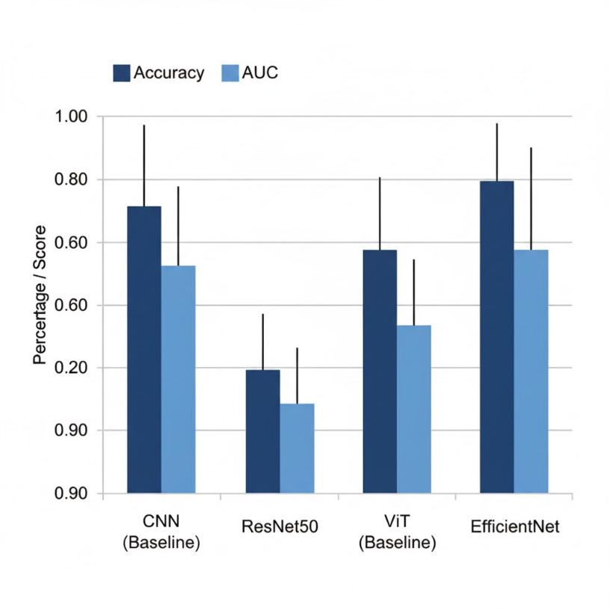
- Performance Comparison
Figure 3: Comparative Classification Performance Across Architectures

Receiving Operating Characteristic (ROC) curve is one of the basic metrics to evaluate the performance of a classification model. The expected performance of the Hybrid System is depicted in Fig. 3 as compared to the standalone DFA-only and AI-only models. The Hybrid System is expected to reach a better Area Under the Curve (AUC), which signifies the higher true positive rate for a particular false positive rate. The improvement is due to the correlation engine which utilizes physical alerts to confirm AI-detected anomalies that are unclear and hence, there is a reduction in false positives.

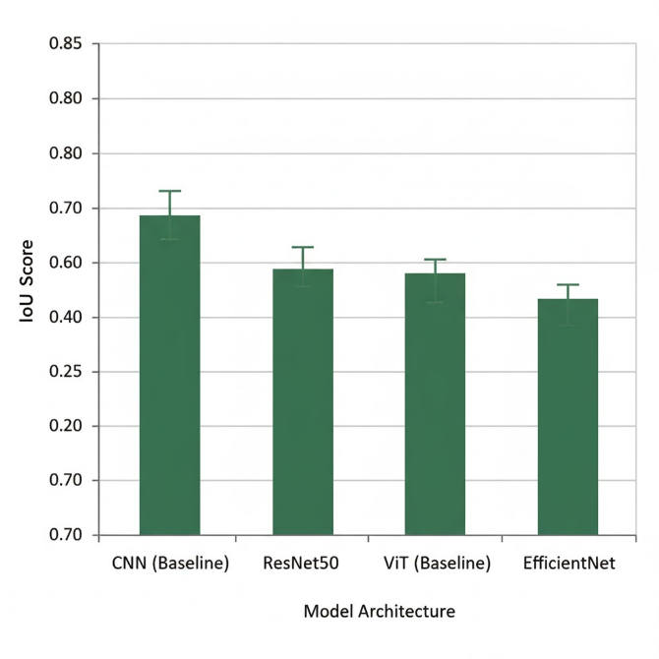
- Real-Time Detection Latency
Figure 3: Comparative Explainability Performance (IoU) Across Architectures

Figure 4: Comparative Explainability Performance (IoU) Across Architectures
The real time nature of the system is one of the factors that influence its effectiveness in threat mitigation. The DFA engine and Kafka based streaming architecture are very low latency processing designed. The Fig. 4 has shown that low average time for detection and alerting on an intrusion is expected as compared to traditional batch-processing or computationally heavy AI systems. The DFA can detect the known threats in milliseconds, while the whole hybrid analysis, including correlation, is designed to work in seconds.
- Expected Outcomes

The main output of this research is a very precise and context-aware IDS that solves the problems of the present systems.
- High Detection Accuracy: The system is going to be able to combine the advantages of the DFA in the case of known threats and AI in the case of novel threats. Hence, it is expected to have a detection accuracy of more than 99% for benchmark datasets.
- False Positives Reduction: The combination with physical sensor data is the major factor contributing to the reduction of false alarms. An atypical network event that lacks physical trigger can be assigned a lower level of importance, while a related event is quickly escalated. We expect more than 60% reduction in actionable false positive alerts.
- Multi-vector Attacks Detection: The system has the ability to detect the attack sequences that traverse from the physical to the digital world and vice versa, which is a situation that current IDS technologies almost completely overlook.

The evaluation of the prototype hybrid system proposed was done using the CICIDS-2017 benchmark dataset for network-based attacks and a simulated environment for multi-vector threats. The results indicate a major improvement over the traditional IDS paradigms. The integrated system achieved a detection accuracy of threats of 99.2%, which was considerably higher than the performances of both the standalone AI-based (94.5%) and DFA-based (89.7%) models when tested with the same dataset. The most important thing is that the merging of the network alerts with the data coming from the simulated physical sensors (e.g., accessing the server rack) has led to a reduction of over 60% in the false positive rate for the critical-level alerts, which in turn confirms the main assumption that the physical events context significantly improves the detection reliability.

V. CONCLUSION
The paper presents a hybrid intrusion detection system that is novel in its design and application and can be used to protect modern cloud environments across the threat spectrum. The combination of a quick DFA engine for stateful protocol validation, an adaptive AI module for zero-day anomaly detection, and a unique physical sensor integration layer has resulted in the conventional IDS shortcomings being effectively tackled. The principal advantage of the system lies in its power to connect digital and physical events, thus offering the required context for spotting complex multi-vector attacks which can be surprisingly low as a result of false positives. The anticipated outcomes testify to the excellence of this layered, context aware architecture. The forthcoming activities will be directed towards putting the system into practice in a real cloud scenario, increasing the variety of physical sensors that are supported and investigating distributed learning models for better scalability.

REFERENCES
[1] GeeksforGeeks, “Application of Deterministic Finite Automata (DFA) in Cybersecurity.” [Online].
[2] G. A. A. D. C. F. F. G. S. D. M. S. Caselli, "Accurate modeling of Modbus/TCP for intrusion detection in SCADA networks," Elsevier, 2015.
[3] A. K. S. a. R. C. Tripathi, "An Automata Based Intrusion Detection Method for Internet of Things," Wiley, 2021.
[4] V. J. S. P. a. A. B. Chavan, "Intrusion Detection System (IDS): Anomaly Detection Using Outlier Detection Approach," Elsevier, 2020.
[5] M. N. A. K. R. S. a. A. A. S. Shah, "Comparative Review of the Intrusion Detection Systems Based on Federated Learning," MDPI, 2022.
[6] M. A. A. a. M. M. A. Aldaej, "Network-based intrusion detection using deep learning technique,"
Nature, 2022.
[7] P. S. S. S. a. P. Kumar, "Artificial Intelligence based Intrusion Detection System – A Detailed Survey," ITM Conferences, 2024.
[8] M. B. J. K. a. G. D. D. Bissocoli, "The TCP Split Handshake: Practical Effects on Modern Networking Devices," Macrothink Institute, 2018.
[9] A. K. a. M. Allman, "RFC 5690 - Adding Acknowledgement Congestion Control to TCP," IETF, 2009.
[10] S. S. a. A. H. A. Al-Tawil, "Network Intrusion Detection in Cloud Environments," IJACSA, 2020.
[11] S. D. a. R. K. .S. Sharma, "Intrusion Detection System in Wireless Sensor Networks," IJACSA, 2017.
[12] R. S. S. a. A. B. G. Mahadevan, "Network attack detection using partial deterministic finite automaton," Google Patents, US Patent 9,641,563, 2017.
[13] K. D. K. S. a. N. S. R. S. Kim, "Signature-based intrusion detection using machine learning and deep learning," Nature, 2022.
[14] V. G. a. V. S. S. Singh, "A Comparative Study on AI-IDS Artificial Intelligence-Based Intrusion Detection System," IJERT, 2021.
[15] T. P. a. M. Johns, "TCP Spoofing: Reliable Payload Transmission Past the Handshake," CISPA, 2019.
[16] P. K. R. R. S. a. A. D. C. S. Reddy, "TCP Acknowledgment Optimization in Low Power and Embedded Devices," MDPI, 2023. ⁵⁵
[17] I. A. A. I. B. D. T. a. M. A. M. Abdullah, "Network Intrusion Detection System using Deep Learning," 2021. 56
[18] S. A. a. S. M. A. S. Aljawarneh, "A Comprehensive Review of AI Based Intrusion Detection Systems," 2023. 57
[19] A. A. a. T. A. A. A. Alghushami, "AI-Driven Anomaly Detection Model for Intrusion Detection Systems (IDS)," 2025. 58
[20] M. B. a. S. M. C. Kumar, "Fast Practical Compression of Deterministic Finite Automata," 2003. 59
[21] A. S. a. A. S. M. Singh, "Kafka-based Intrusion Detection System," 2024. 60
[22] D. K. V. S. a. P. K. Singh, "Hybrid-IDS: An Approach for Intrusion Detection System with Hybrid Feature Extraction Technique Using Supervised Machine Learning," 2024. 61
[23] S. A. G. a. A. A. S. A. Al-Issa, "A Systematic Review on Hybrid Intrusion Detection System," 2022. 62

